Earth Sci 2B03

Laboratory #3

Hydraulic Conductivity

Jatin Chowdhary

David Camacho

Lab Section #5

400033011

**Part I: Lab Component**

1.

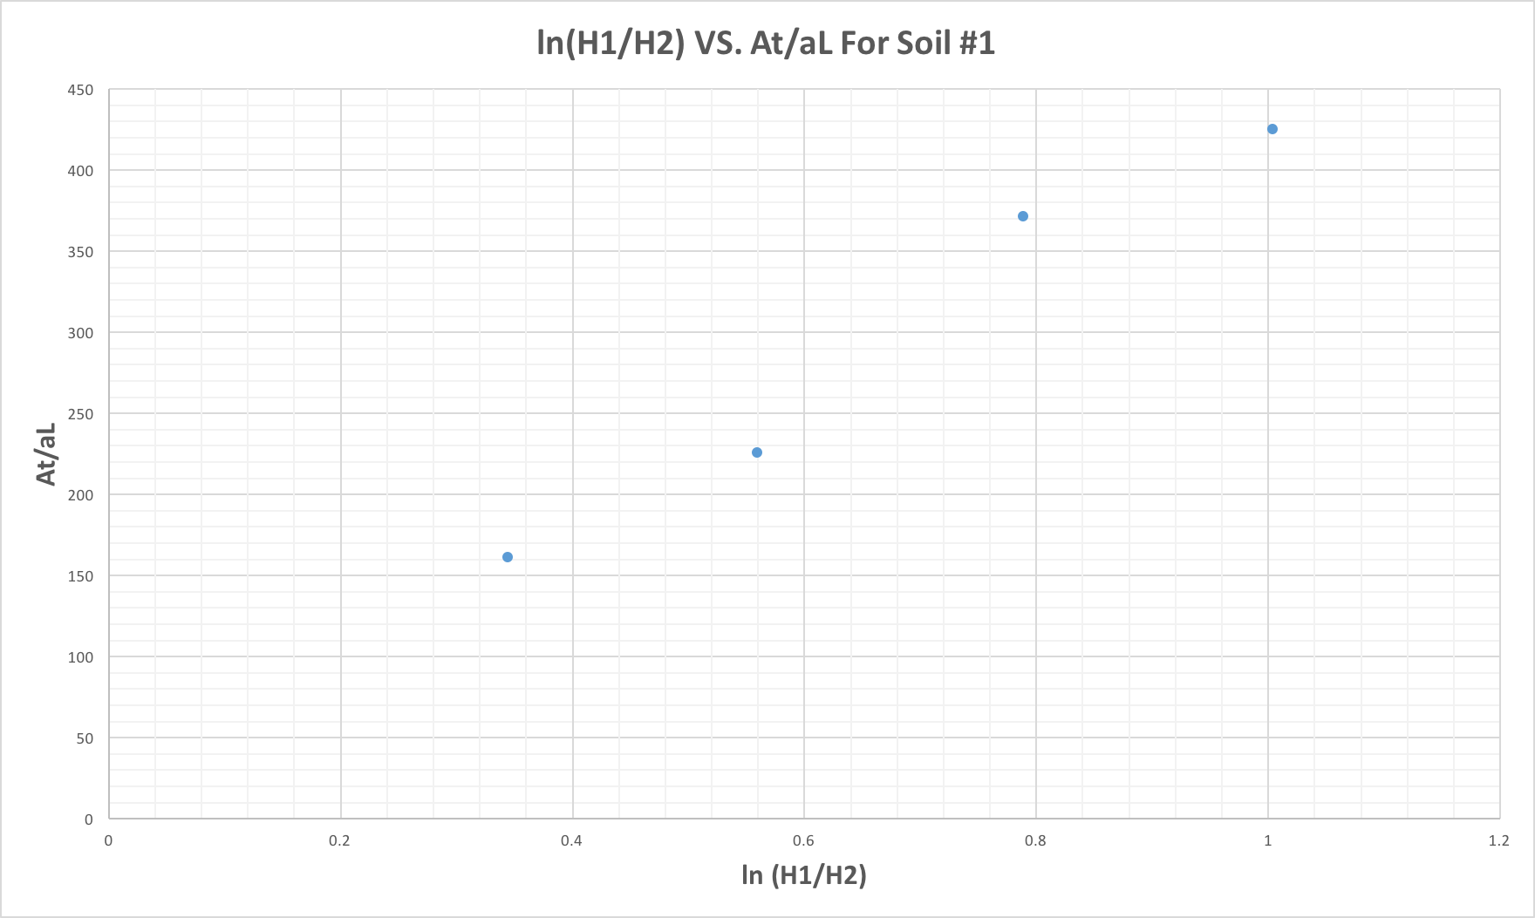

Figure 1: Graphs the falling head data for Soil #1. Ignore the line of best fit going out of bounds; Microsoft Word is horrible for graphing.

Slope = (Y2 – Y1) / (X2 – X1)

Slope = (200 – 0) / (0.467 – 0)

Slope = 428.2655246

Slope ≈ 428.27

The average saturated hydraulic conductivity for soil #1 is 428.27 cm/s

Soil #1 has a high hydraulic conductivity, which means that soil #1 allows water to flow freely through it. This indicates that soil #1 must have a lot of pores, especially large ones, to allow water to percolate through it.

There are not enough points to conclude whether the line of best fit should be linear or curve. However, I think that it should be curved, because water at the top of the glass tube increases the pressure and causes water to escape more quickly from the spout. As the amount of water in the glass tube decreases, the pressure does too, hence the rate at which water leaves through the spout also decreases. So, the slope (or Ks) is large in the beginning, and over time, gets smaller and smaller, as water escapes the glass tube

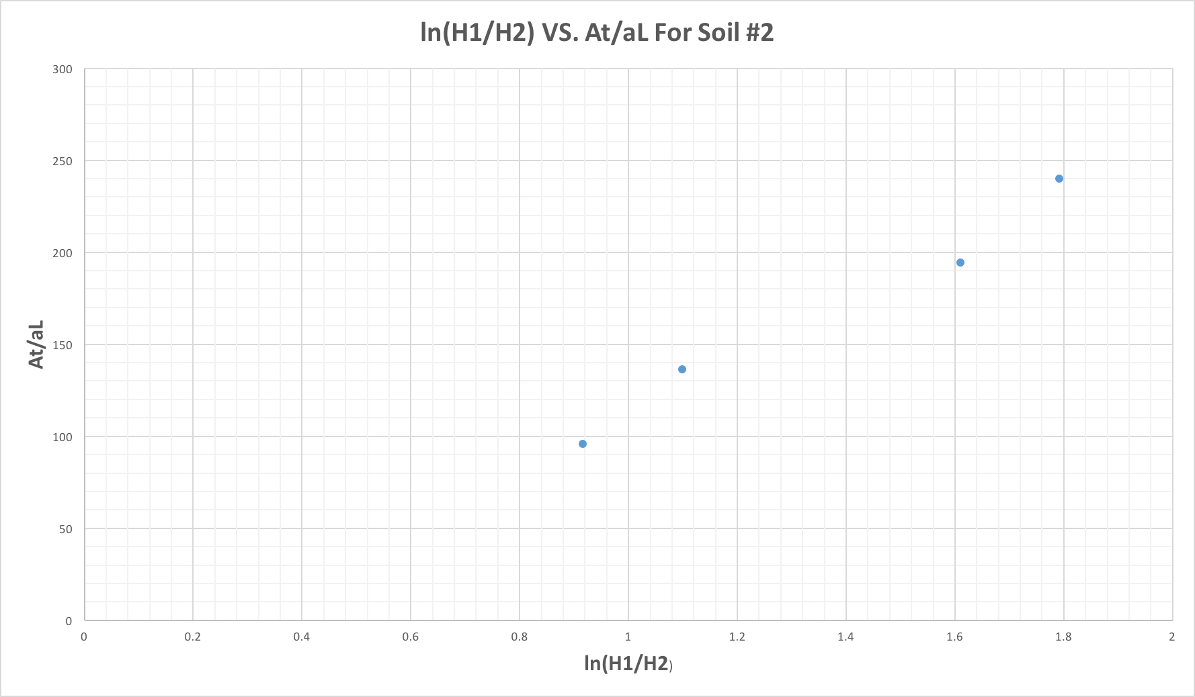

Figure 2: Graph of the falling head data for Soil #2

Slope = (Y2 – Y1) / (X2 – X1)

Slope = (200 – 0) / (1.62 – 0)

Slope = 123.4567901

Slope ≈ 123.46

The average saturated hydraulic conductivity for soil #1 is 123.46 cm/s

Soil #2 has a low hydraulic conductivity, relative to soil #1, which means that soil #2 does not allow water to freely flow through it as much. This indicates that soil #2 must not have a lot of pores, hindering waters ability to flow through out.

There are not enough points to conclude whether the line of best fit should be linear or curve. However, I think that it should be curved, because water at the top of the glass tube increases the pressure and causes water to escape more quickly from the spout. As the amount of water in the glass tube decreases, the pressure does too, hence the rate at which water leaves through the spout also decreases. So, the slope (or Ks) is large in the beginning, and over time, gets smaller and smaller, as water escapes the glass tube

2. The variation in Ks values for both soils is not too significant. For soil 1, the Ks values average around 2.27 x 10-3, with the highest value being 2.48 x 10-3, and the lowest is 2.121 x 10-3. For soil 2, the Ks values average around 8.4 x 10-3, with the highest being 9.57 x 10-3, and the lowest is 7.63 x 10-3. For soil 2, the values deviate more, but that can just be random variation. All values hover around the 10-3 magnitude. The values of Ks for soil 1 are not identical, and neither for soil 2. This is because of error, both human and experimental. Firstly, it is possible that the rubber stopper inside the cylinder was not air tight, and some water leaked through it. The force keeping the rubber stopper and the cylinder is friction; this is the only force keeping these two objects stuck together, and keeping the apparatus from falling apart. However, with the addition of water, the force of friction decrease and in this experiment, it could have caused water to leak through the apparatus. This is a plausible reason for why the Ks values are not the same. Secondly, gravity can also marginally alter the Ks values. The water at a height of 30cm has more pressure than the water at 10cm. This extra pressure acts as an external force, pushing the water harder through the glass tube/rod. In order to avoid this error, the trial values for H1 and H2 should have been the same. For instance, 30 🡪 15, 30 🡪 5, etc. This keeps the gravitational pressure for the water same across all tests. Finally, there could be a human error, where the recorded values are inaccurate because the timer and Hx readings where not read on time; delay between realizing that the water has crossed the Hx marking, and pressing the timer or signaling your partner to stop it.

3. Based off of figure #3, soil #1 is fine sand, and soil #2 is sand. This is because soil #1’s Ks values are around 2 x 10-3, which leans more toward 10-4. Soil #2’s Ks values are around 8 x 10-3, which leans toward 10-2. Hence, soil #1 is fine sand, and soil #2 is sand. However, these readings are inconsistent with the observed textural findings. It does not make sense that soil #1 is fine sand and it does not make sense that soil #2 is sand. This is because fine sand will have a lower hydraulic conductivity than sand. The data shows that soil #1 (fine sand) has a higher hydraulic conductivity than soil #2 (sand). This is impossible because fine sand has less empty pores due to its smaller grain size, and sand has more empty space due to its larger grain size. Imagine a jar full of golf balls versus marbles. The golf balls represent soil #2 (sand) and the marbles represent soil #1 (fine sand). There is less empty space in the jar of marbles, for water to flow through, relative to the jar of golf balls. The jar of marbles will have a lower hydraulic conductivity than the jar of golf balls. Similarly, soil #1 should have a lower hydraulic conductivity than soil #2. However, this is not the case; the opposite is true. Therefore, the textural classification is not consistent with the observed texture. The findings of the data do not support our conclusion about the soil texture. In reality, soil #1 should be sand, and soil #2 should be fine sand, because soil #1 has a higher hydraulic conductivity than soil #2.

4. The bulk density of soil 1 is about 0.96g/cm3, and for soil 2 it is 1.03g/cm3. I did expect these values because as bulk density increases, soil hydraulic conductivity decreases, and as bulk density decreases, soil hydraulic conductivity increases. This is because as bulk density increases, so does compaction, and compaction can impede the movement of water. This relationship holds true, vice versa. According to the data, soil #1 has a high hydraulic conductivity, relative to soil #2. And high hydraulic conductivity equals to low bulk density, and vice versa. Soil #1 has a higher hydraulic conductivity than soil #2, and a lower bulk density than soil #2. This makes sense because bulk density refers to the dry mass of soil divided by the volume. A low bulk density means less compaction, while a high bulk density, means more compaction. Since soil #2 has a higher bulk density than soil #1, it is compacted more, pores are diminished, thus hydraulic conductivity should be lower than soil #1; and it is.

**Part II: Comprehensive Questions**

1. Hydraulic conductivity, and ultimately, pores. Hydraulic conductivity depends on pore space geometry of the soil because the connection of pores and their size and shape determine water flow pathways. Pore space, and pore sizes determine water flow pathways, and ultimately, the ability of water to flow through soils. Generally, the larger the pore sizes, the more easily water will flow through the soil. For example, coarse sandy soils usually have larger pores and thus they generally have a higher saturated hydraulic conductivity than soils like clay and silt. Clay and silt are finer textured soils, explaining their low hydraulic conductivity. Clay and silt have smaller pores, hindering the ability of water to flow through them. Sand that is coarse and sorted well, will have a high hydraulic conductivity, compared to fine silts and clay.

2. Grain size, bulk density, sorting and grading, and pore space and sizes, would influence a soil’s saturated hydraulic conductivity. Grain size would affect SHC because soils with fine grains would be smaller and it would be harder for water to run through them, as opposed to soils with coarse grain sizes. Just imagine a jar full of round bb pellets, and another jar full of golf balls. If you were to pour water down both of them, water would touch the bottom of the jar with the golf balls first because exposed surface area of all the golf balls combined is smaller than the surface area of the bb pellets. An increase in surface area results in greater surface tension, slowing down the movement of water. Also, the jar full of bb pellets acts somewhat as a barrier and somewhat slows down the movement of water. Now, imagine if that jar of bb pellets was filled with even smaller bb pellets, and micro-beads that fill in the gap between the bigger bb pellets. This is the sorting and grading effect. Poorly sorted soil will have lower SHC because the smaller grains occupy the empty pore space, and act as a barrier, which impedes the movement of water even more. Furthermore, bulk density affects SHC. Bulk density refers to the dry weight of soil per unit of volume, which is an indication of compaction. Soils with a high bulk density – soils that are highly compacted – will have a lower SHC because of the absence of pores. Soils with a low bulk density are not compacted and have pores which allow for the free movement of water.

3. Macro-pores are defined as the cavities within soils. Macro-pores, as the name suggests, are large holes found within soils (macro meaning large, and pore meaning holes). These pores are created by worms, dead root channels, soil cracks, and soil fauna. Macro-pores can account for a large proportion of the water movement in saturated soils. Macro-pores can increase the hydraulic conductivity of a soil. This is because macro-pores are essentially large pores, and using knowledge from the question above, we know that the larger the pores, the easier the movement of water; increasing the hydraulic conductivity. Macro pores allow for better drainage of soils, and percolation of water throughout the soil. Imagine a jar of soil, filled to the top. Now imagine a person taking a giant needle, and poking several holes into the soil at various lengths. Simply put, the needle is creating macro-pores, allowing the water to flow more freely, thus increasing hydraulic conductivity.